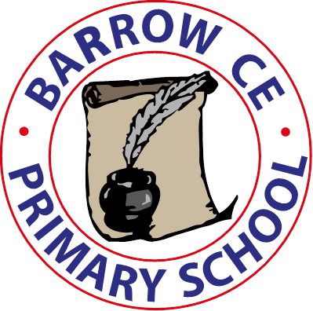

**Barrow C of E Primary School**

**School Term Dates 2025-26**

**Autumn Term 2025**

**Monday 1st September INSET Day**

Tuesday 2nd September School re-opens

Thursday 23rd October School closed for half term

**Friday 24th October INSET Day**

Money 3rd November School re-opens

Friday 19th December School closes for Christmas holiday

**Spring Term 2026**

**Monday 5th January School INSET Day**

Tuesday 6th January School re-opens

Friday 13th February School closes for half term

Monday 23rd February School re-opens

Thursday 2nd April School closes for Spring Break

**Summer term 2026**

Monday 20th April School re-opens

Monday 4th May school closed for Bank Holiday

Friday 22nd May School closes for half term

**Monday 1st June INSET Day**

Tuesday 2nd June School re-opens

Tuesday 21st July School closes for summer holidays

**Wednesday 22nd July INSET Day**

**Autumn Term 2026**

Tuesday 1st September 2026 – **INSET DAY**

**Wednesday 2nd September 2026 School re-opens**