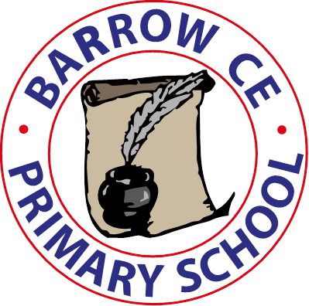 | Barrow CE Primary School  Charging and Remissions Policy  November 2024

Policy on charging for, and remissions for, school activities

- At Barrow CE Primary School, we believe that all our pupils should have an equal opportunity to benefit from school activities and visits, both curricular and extra-curricular, independent of their parents’ financial means. This charging and remissions policy describes how we will do our best to ensure a good range of visits and activities is offered and, at the same time, try to minimise the financial barriers which may prevent some pupils taking full advantage of the opportunities.

- The policy identifies activities for which:
- charges will not be made
- charges will be made
- charges may be waived

Voluntary contributions

- Separately from the matter of charging, schools may seek voluntary contributions in order to offer a wide variety of experiences to pupils. All requests for voluntary contributions will emphasise their voluntary nature and the fact that pupils of parents who do not make such contributions will be treated no differently from those who have.

- When organising school trips or visits which enrich the curriculum and educational experience of the children, the school invites parents to contribute to the cost of the trip. All contributions are voluntary. This statement is always included in letters to parents. If we do not receive sufficient ‘voluntary contributions’, we may cancel a trip. If a trip goes ahead, it may include children whose parents have not paid any contribution. We do not treat these children differently from any others.

- Sometimes the school pays additional costs in order to support the visit usually using School Fund or contributions from PTFA, and funds provided by Pupil Premium to subsidise costs if needed for eligible pupils.

- The following is a list of typical additional activities organised by the school, which require voluntary contributions from parents. This is not an exhaustive list:
- visits to museums
- educational school trips linked to curriculum
- sporting activities which require transport expenses
- outdoor adventure activities
- visits to the theatre
- musical events

- The Headteacher will have discretion to pay from the budget of Barrow CE School to assist in the whole or in part any student whose means would not enable them to pay for a particular activity for which charging is permitted.

Residential Trips

- All residential trips are individually approved by governors. The school accesses grants or donations in order to subsidise the cost of such trips. All families are offered the opportunity to pay for trips in instalments over as long a period of time as possible, up to 6 months, and families are made aware that they may approach the school in confidence if they have concerns regarding payment.

Music tuition

- All children study music as part of the normal school curriculum. We do not charge for this. There is a charge for individual or group music tuition if this is not part of the National Curriculum. The peripatetic music tutors teach individual or small group lessons and make a charge privately for these lessons.

Swimming

- The School organises swimming lessons for all children in Key Stage 2. They take place at Christleton High School in school time. We do not ask parents for a voluntary contribution towards the cost of transport in order that they can take place. School pays for the cost of the teaching provided by an external teacher.

Activities outside the National Curriculum

- Activities lying outside of the National Curriculum, and taking place outside school time, will be charged in full.

General

- All charges will be reviewed annually and revised in line with appropriate inflation factors. Where appropriate VAT will be charged and properly accounted for in accordance with the appropriate VAT regulations.

- The school may require parents to pay for damage to or loss of school property for which their children are responsible where reimbursement is appropriate. This will be at the Headteacher’s discretion.

School Lunches

- School lunches are provided for the children by Cheshire West & Chester local authority’s Edsential catering. Payment for lunches is administered by the school. Charges for school meals follow the requirements of the Local Authority. Parents pay weekly.

- When arrears occur then the school informs parents by letter of the amount owing and a request that this should be paid. The school will always take reasonable steps to settle the matter with a family as the wellbeing of the child will be a priority. In extreme circumstances the school reserves the right to no longer provide any further meals, to contact social services regarding a child’s welfare and to refer the matter to the LA legal department to issue a demand for payment.

Support for Parents on Low Incomes

- Barrow CE School will advise all parents of the assistance they can expect if they are on low incomes. When we inform parents about a forthcoming visit, we will make it clear that parents of children who are on FSM will receive support towards the cost of board and lodging or the trip itself if it is not overnight.

Monitoring and review

- The headteacher monitors this policy on a regular basis and reports to governors, when requested, on the effectiveness of the policy. The governing body monitors this policy on a bi-annual basis.

Created: November 2019
Reviewed: November 2024
Next Review: November 2025

