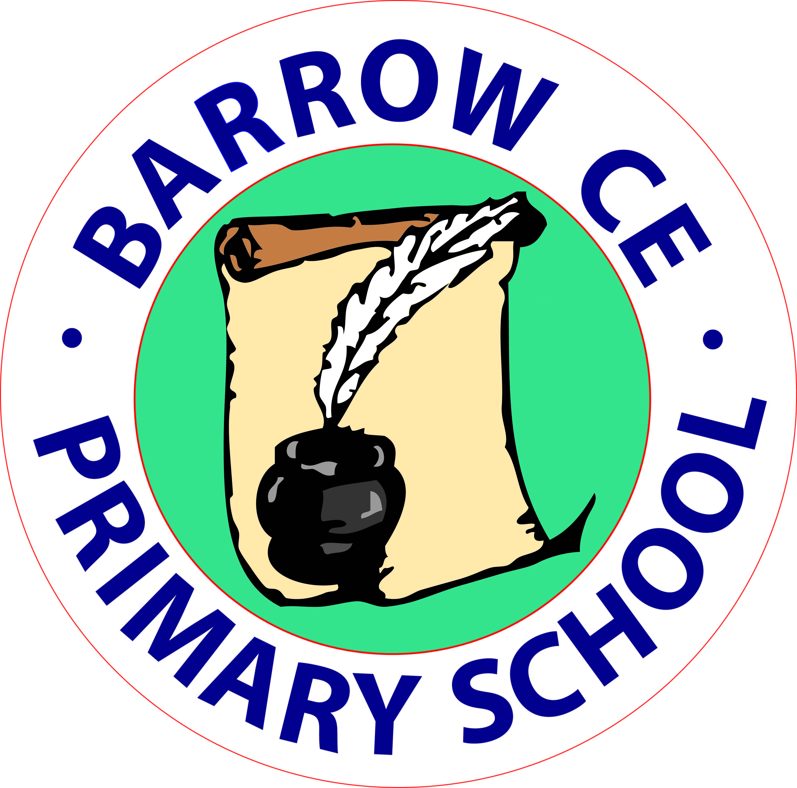 Barrow C of E Primary School

Great Barrow

Near Chester

CH3 7HW

Tel 01244 981313.

head@barrowce.cheshire.sch.uk

Headteacher

Mr. A. Ramsden B.Ed. Hons. NPQH

Dear Parents

On behalf of all the staff and Governors welcome back to the start of what promises to be another exciting and eventful year at Barrow C of E School. A very special welcome goes to all of the new children and their families, who have joined us this September for the first time.

It has been great to welcome the children back to school after the break and last week, during my assembly, we talked once again about how important all of the children and adults were to our team and all the things we can do to make our school the very best it can be.

On Monday 4th September all staff had a successful INSET day on ‘Talk for Writing’ at Cuddington School. Our main priority has been, and continues to be, to look for ways to enhance and extend the excellent quality of teaching, learning and care provided for the children.

As you are probably aware I am leaving and starting a new post in January 2017 at a bigger school nearer to my home on the Wirral. Barrow school is in a good place at the moment with a good OFSTED report, a great set of end of year results, rising numbers and strong Governance. Most of all Barrow has a talented hardworking and dedicated staff who will continue to provide a varied and exciting curriculum for your children. The Governors are looking at staffing and new appointments from January and will be contacting you shortly.

On 27th September we will be holding an open day from 9.15-11.30am and 1.30-3.00pm. You will have the opportunity to have a tour around the school following a harvest trail. All are welcome and if you know of any prospective children and parents who are interested in the school please let them know. On the same day we will also be holding a coffee and cake afternoon supporting Macmillan charity. Refreshments will be served in the school hall from 1.30 until home time. Why not combine the two enjoy a drink and something to eat then have a tour of the school?

Miss Hughes has put an exciting package of clubs together for this half term. Clubs include singing, music, gym and tag rugby. Please look on the website for more details or contact Miss Hughes in the office.

Harvest festival is on 29th September at 2pm. This year we are having a tinned harvest collection in partnership with the Church for Save the Family. Any donations of canned or dried goods would be gratefully received.

The website had been updated with all current dates up to Christmas and will continue to be updated over the next few weeks. [www.barrowcofeschool.com](http://www.barrowcofeschool.com)

Andy Ramsden.

[](https://www.google.co.uk/url?q=http://allsaints.stmarysacademytrust.co.uk/2016/11/09/outstanding-siams-report/&sa=U&sqi=2&pjf=1&ved=0ahUKEwjp943O1IXUAhUhAcAKHXiIAGAQwW4IIjAG&usg=AFQjCNEMkTwf-KUz8CC3YXqIe54kdZDdDw)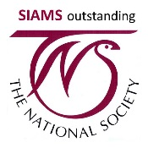[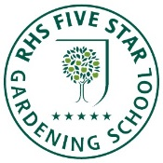](http://apps.rhs.org.uk/schoolgardening/teachershome/benchmarkscheme/default.aspa)

